***Umair’s Counter***

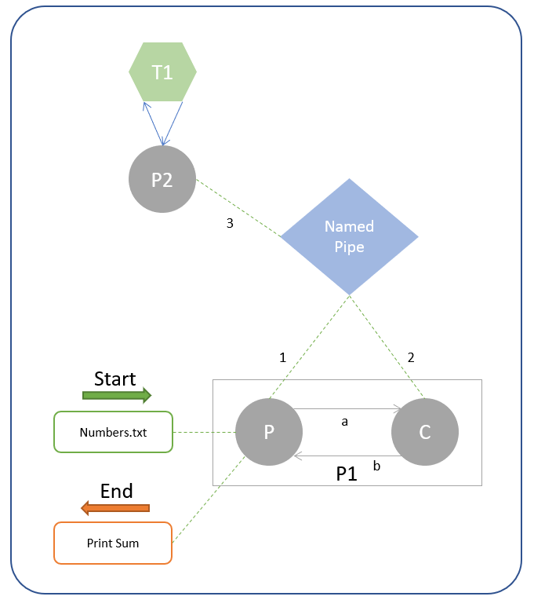

* *P1 program:*
* *Parent receives the name of a file as a command line argument.*
* *Parent sends the name to a named pipe [1] and Parent also sends a signal to Child [a] that it has sent contents.*
* *Child should only try to read an output from named pipe, if it has received a signal from Parent.*
* *After reading the results from named pipe [2], Child sends the results to Parent [b].*
* *Parent should display the results.*
* *P2 program:*
* *Program reads the filename from named pipe [3]*
* *Program initializes threads. (the no. of threads = the no. of rows in the file)*
* *Each thread is given a row of the file.*
* *Each thread returns the sum of all the numbers in that row.*
* *Program adds the results of all the threads to get a total_sum.*
* *Program writes that total_sum to the named pipe [3], and displays it on the screen before terminating.*
* *Execution:*

*Type “make run” in terminal. Ignore the warnings and match your results with the provided results.*

*Note: make use of wait to achieve synchronization.*